Aleksas Murauskas

ECSE 422

Assignment 2

1. Show that the Hamming distance of an M-of-N code is 2.

Hamming distance

1. Briefly explain the following (AND show an example of each): codeword, hamming distance, separable code, and non-separable code

Codeword: Code word is an encoded data word. It is larger than data word and must be decoded in order to read the data word. A data word with a parity bit is an example.

Hamming distance: Is the number of bits that would need to change to turn one dataword into another. 1001 and 1100 have a hamming distance of 2. The even bits would need to flip to become the other codeword.

Separable code: Codeword is separable if it has separate fields for data and code bits. A parity bit is the simplest separable code type.

Non-separable: data and code bits are integrated together, extracting the data from encoded word requires processing. M of N codes are non-separable.

1. Define overlapping parity. If you have 4 data bits and 2 parity bits, is this working overlapping parity?

Overlapping Parity: Each data bit is covered by more than one parity bit.

In order to be a proper parity bit $2^{r}≥d+r+1$ where r is # of parity bits and d is data bits. With d=4 and r=2, $2^{2}=4≥ 7=4+2+1$ since this inequality is not true, this overlapping parity does not work.

1. What is Berger code? Describe how it works. What are two advantages of using Berger code over other codes?

Berger Code a separable code that codes as follows: count the # 0f 1’s in dataword, express the found # in binary, complement the found binary number, append to the end of the data word.

Berger code advantages: low overhead, smallest number of check bits of all separable codes

1. Use Separable Hamming (7,4) to encode 1011. Given you receive 1111001, find the syndrome. Comment on the error correction and detection capabilities.

Separable Hamming 7,4 is coded as $a_{3}a_{2}a_{1}a_{0}p_{2}p_{1}p_{0}$, where $p_{0}=a_{0}+a_{1}+a_{3}$,

$p_{1}=a_{0}+a_{2}+a_{3}$, $p_{2}=a_{1}+a_{2}+a_{3}$, $p_{0}=1+1+1=1$, $p_{1}=1+0+1=0$, $p_{2}=1+0+1=0$

The result is 1011001

Given 1111001

Found parity’s from return are $p_{0}=1, p_{1}=1,p_{2}=1$

111 doesn’t match the expected parity bit. Syndrome is 001+111=110. Therefore bit $a_{2}is incorrect$

1. Using (separable) CRC-16, polynomial G(x) = X4 + X3 + 1, encode the data word 1011 to find the codeword. Give the final codeword in binary format.

Data word = $x^{3}+x+1$

Multiply D\*G= $\left(x^{4}+x^{3}+1\right)\left(x^{3}+x+1\right)=\left(x^{7}+x^{6}+x^{3}\right)+\left(x^{5}+x^{4}+x\right)+\left(x^{4}+x^{3}+1\right)$

$x^{7}+x^{6}+x^{5}+2x^{4}+2x^{3}+x+1$-> $x^{8}+x^{4}+x+1$

Final codeword is: $100010011$

1. Using (separable) cyclic (7,4) m-k code, generator polynomial G(x) = X3 + X + 1, encode the data word 1001 to find the codeword. Introduce the error E(x) = X2 + X + 1. What is the new codeword? Perform a check. Give the final codeword in binary format.

Code word = 1001\*1011=

0001001+0010010+0000000+1001000= 011011+1001000= 01100011.

With error E= 111.

1. Describe in detail the relationship between buffering and checkpointing.

The process of checkpointing begins by writing it’s state to an internal buffer. The CPU can continue to execute while the checkpoint is written from buffer to disk. The buffer can have memory protection of types read-write, read only and inaccessible. In incremental checkpointing, only the changed portions of the buffer need to be rewritten.

1. What is an advantage of distributed recovery blocks over non-distributed recovery blocks?

Distributed recovery blocks allow a better balanced computational load across multiple processors. Each processor can have a local disk to write to. Breaking the checkpoints amongst different blocks allows faster recovery as some parts of the checkpoint state doesn’t need to be reset.

1. What is a recovery line? Draw an example of a useless checkpointing scenario. Describe in words what is occurring.

Recovery lines are a consistent set of check points that can be rolled back to and restart from that point.

Below Q2 is a useless checkpoint.

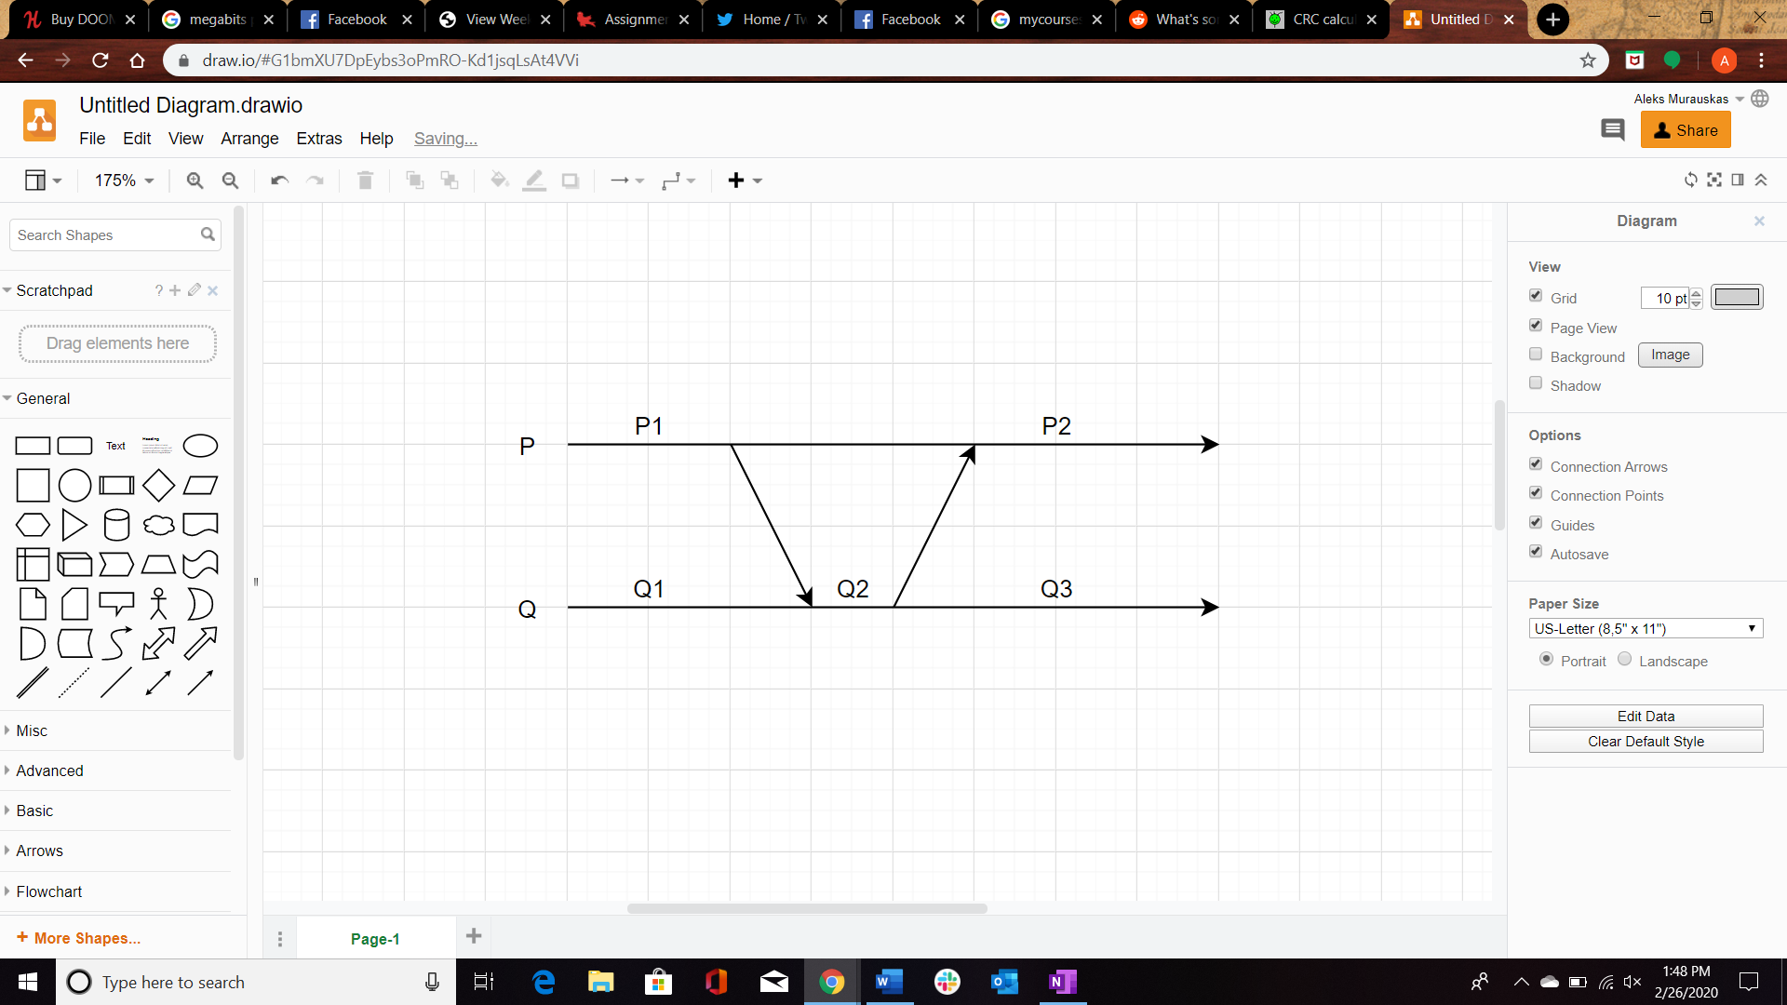

In the case of Q2 there is a receipt of receiving the first message, but not sending the second. It cannot be partnered with P1 since the first message has not been sent in P1’s case. It cannot be partnered with P2 since Q2 has no receipt of sending P2, in both cases the messages would become orphans.

Q